**Online diary 4**

**Title:** Create a game where the players must work together to defuse a ‘bomb’.

**Date:** Tuesday 27th October 2020

**4.0 Background:**

A team working defusal game where two players must complete different puzzles and tasks in order to defuse the bomb and save the day. The players are given different tasks in order to find out a way to defuse the bomb. If they do not defuse it, they end up dying and fail the task.

**4.1 Game:**

A team working game called “Bomb defuser” was created. This game utilises common knowledge and solving problem skills. These skills are easily attainable beforehand and during the game, which will lead to the final goal of defusing the bomb. Therefore, if the player defuses the bomb, they will win.

**Rules:**

* The 2 players have 4 minutes to defuse the bomb.
* Complete all four tasks and enter the password to win.
* Every error result in a time penalty of 10 seconds.
* When the timer runs out, the bomb explodes.
* Each completed task gives the players a random letter from the four-letter password.
* Entering the password before the timer is up defuses the bomb.

**How to play:**

The players must complete the four tasks that have been set in order to get the password and defuse the bomb. The four tasks are:

* Cut the three wires in a colour-specific order (Red, Green, Blue).
* Connect wires to diffuser (click and drag, matching colours
* Sudoku (1-4 in each square, row and column)
* Prime Numbers up to 50 (enter 2, 3, 5, 7, 11, 13, 17, 19, 23, 29, 31, 37, 41, 43, 47 on the number pad)

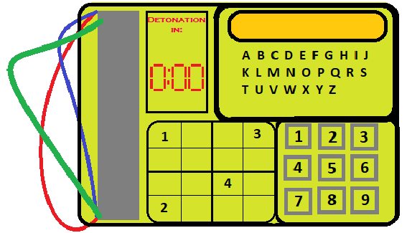

E

D

C

B

A

***Figure 1 shows the bomb, where [A] is the wires, [B] is the Sudoku puzzle, [C] is the number pad for the prime numbers, [D] is where to put the password in and [E] shows the Timer.***

**Play testing:**

There was some playtesting taken place which was done by Steve Yap. During the play testing, the following feedback that were received was:

* In task 2 the players may not know where to locate the defuser.
* In task 3 sudoku may be too long, however it would be possible
* State how long the players have until the bomb detonates in the how to play manual.

Therefore, with this feedback sudoku had been shortened into a easier version which is a 4x4 sudoku as shown in figure 1. This means that they can easily complete the game without consuming too much time to complete.

**Project members:**

The group had consisted of Rowan Noble, Jamie Smith, Reece Taylor, Akash Sroay.